# Read Financial CSV with Parsed Dates

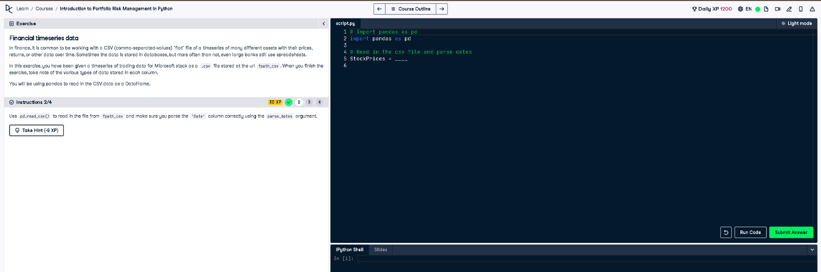

## ✅ Full Correct Answer:

# Import pandas as pd  
import pandas as pd  
  
# Read in the csv file and parse dates  
StockPrices = pd.read_csv(fpath_csv, parse_dates=['Date'])

## 🧾 Explanation (Simple Words):

This code reads a CSV file that contains Microsoft stock trading data. The 'Date' column is automatically recognized as a date using parse_dates. This is helpful for accurate time series analysis and plotting later in the process.